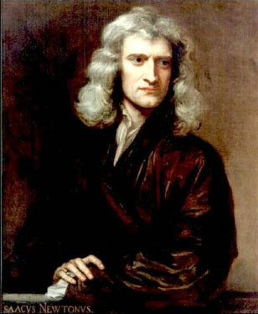

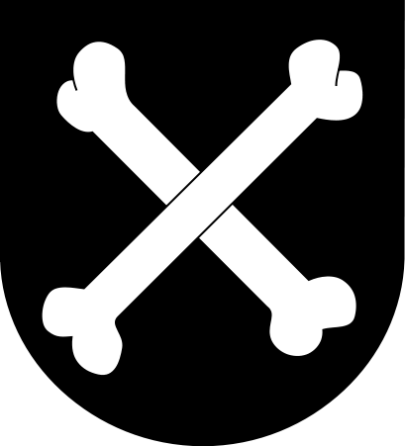
Sir Isaac Newton was born on January 4, 1643 in England. Newton attended Trinity College. He studied the work of Copernicus, Kepler, and Galileo. Basically Newton studied all the sciences and some non-science subjects. Newton loved mathematics; his book entitled Principia was wrote in infinitesimal calculus in geometric form. Newton also loved to study optics. He created a Reflecting telescope and also he investigated refraction of light. Lastly Newton also studied Mechanics and Gravitation. Newton created the three universal laws of motion which are still used today. Newton also had data to back up his Heliocentric view of the universe. For some people Sir Isaac Newton was the greatest man that ever lived. Newton died on March 31, 1727.

